DATE: 01.03.2019
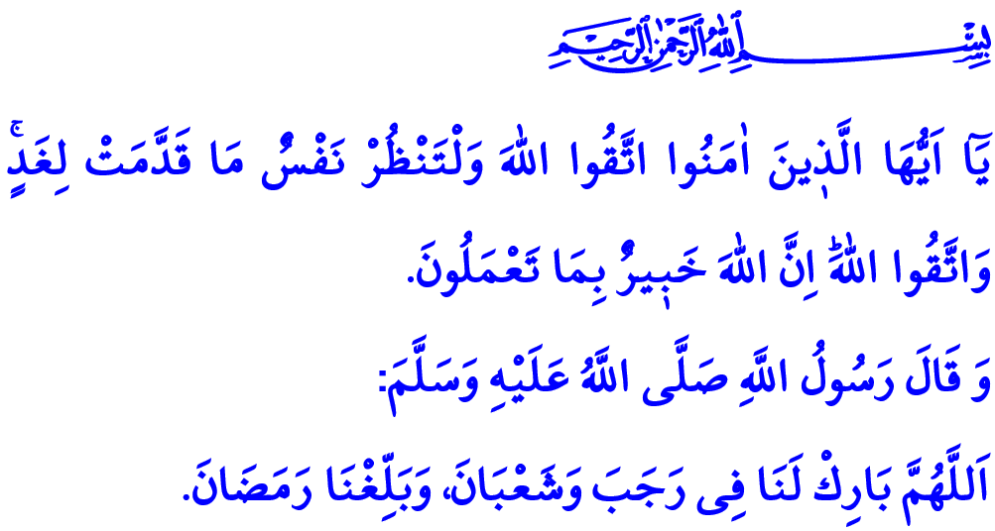
THE THREE SACRED MONTHS: THE SEASON OF BLESSINGS
Honorable Muslims!
The beginning of the three sacred months, which is the season of compassion and mercy, is just around the corner. Thanks and praise be to Allah for allowing us to make it to these blessed days. Peace and greetings be to the Prophet Muhammad (saw) who was sent as mercy to the worlds.
The Night of Raghaib marks the beginning of the three sacred months, which are Rajab, Sha’ban, and Ramadan. Along the way come the Night of Miraj and Bara’ah, and the peak is reached through the Night of Qadr, which is more blessed than a thousand months. Finally, the Eid al-Fitr, which cements our unity and togetherness and increases our fondness and compassion, crowns the three sacred months. The season of the three sacred months is the long-awaited sacred guest at the home of our hearts. In this respect, The Messenger of Allah used to welcome the three sacred months with the following prayers: “O Allah! Bless the months of Rajab and Shaban for us, and allow us to reach the month of Ramadan.”
Dear Believers!
The season of the three sacred months is when the divine compassion is felt all around and the hearts are filled with spiritual peacefulness and serenity. It is on these blessed occasions that we account for the deeds we do in life and make sense of the purpose of creation. We turn towards servitude to Allah, worshipping, doing charitable works and good deeds more than ever, as well as render the world of our hearts prosperous. We get to remember all the duties and responsibilities that we keep neglecting in the rush of life.
Dear Muslims!
Next week Thursday night is the Night of Raghaib, full of virtue and blessings. Raghaib means ‘the longed for, the demanded for, and the valued for’. The Night of Raghaib is the herald of the three sacred months and the news-bringer of Ramadan, the month of the Qur’an. The Night of Raghaib reminds us that the true gain in this life that flows away is to turn towards Allah and keep our promise of servitude to Him.
Honorable Believers!
Allah the Almighty says in the verse I have recited at the beginning of the khutbah, “O you who have believed, fear Allah. And let every soul look to what it has put forth for tomorrow - and fear Allah. Indeed, Allah is Acquainted with what you do.” According to this divine appeal, we as Muslims should look for opportunities to do good deeds more than ever in these three sacred months full of compassion and mercy. There are many ways to do good deeds. Sometimes it can be to show the direction for someone who lost their ways. Some other times it is to rid of an obstacle causing inconvenience for people. Still other times it is to help those people in need and give charity (infaq) to them. Infaq does not always have to be a good deed done by way of giving out an amount of money. The Prophet Muhammad (saw) pointed out to several ways of infaq, with his following saying, “Enjoining all that is good is a Sadaqa.” It is also a kind of infaq to provide a cure or remedy for a patient’s illness. What a noble act it is to be a beam of hope for patients through organ-, bone marrow-, and blood stem cell-donation without expecting anything worldly in return! These kinds of acts as required of our religious and human responsibilities are no doubt among those deeds to help us get the approval of Allah in this atmosphere of blessings and mercy of the three sacred months. As Allah clearly states in the Holy Qur’an, “…whoever saves one (soul) - it is as if he had saved mankind entirely…”
Dear Muslims!
The season of the three sacred months is a door opening to many opportunities for us. We should turn such days and nights into opportunities to get Allah’s approval, on condition that our efforts in this regard do not discontinue once they are past. Our ‘raghaib’ should be for the Almighty Allah for life long.
As I conclude, I would like to congratulate you all for the Night of Raghaib, and pray Allah that the climate of compassion, mercy, and blessedness of the three sacred months contribute to the salvation, peace, and serenity of humanity.

Tabarani, Al-Mu'jam Al-Awsat, IV, 189; Ahmad ibn Hanbal, Musnad, 1, 259.
Hashr, 59/18.
Bukhari, Adab, 33. ⁴ Ma’idah, 5/32. General Directorate of Religious Services

